In order to connect to Twitter’s Streaming API, we must first create an account with Twitter and a Twitter application.

First, if you don’t already have a twitter account, create one at –

<https://twitter.com/>

Next, visit the Twitter apps developer site at -

<https://apps.twitter.com/> and choose the option to ‘sign in’ –

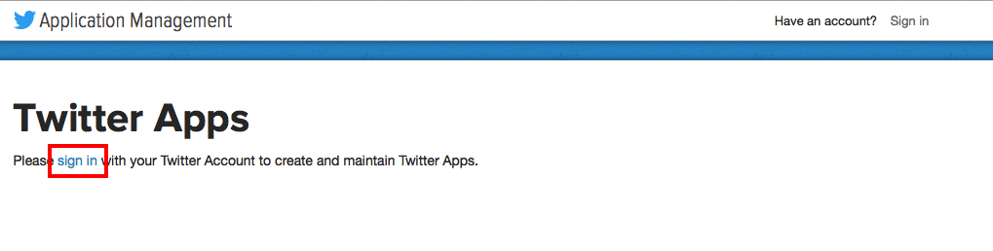

It will state that you ‘don’t currently have any Twitter apps.’ Click the ‘Create New App’ button -

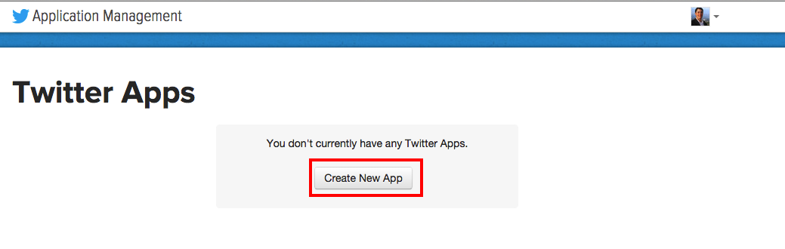

Fill out the ‘Create an application’ form. There are three required fields – Name, Description, and Website –

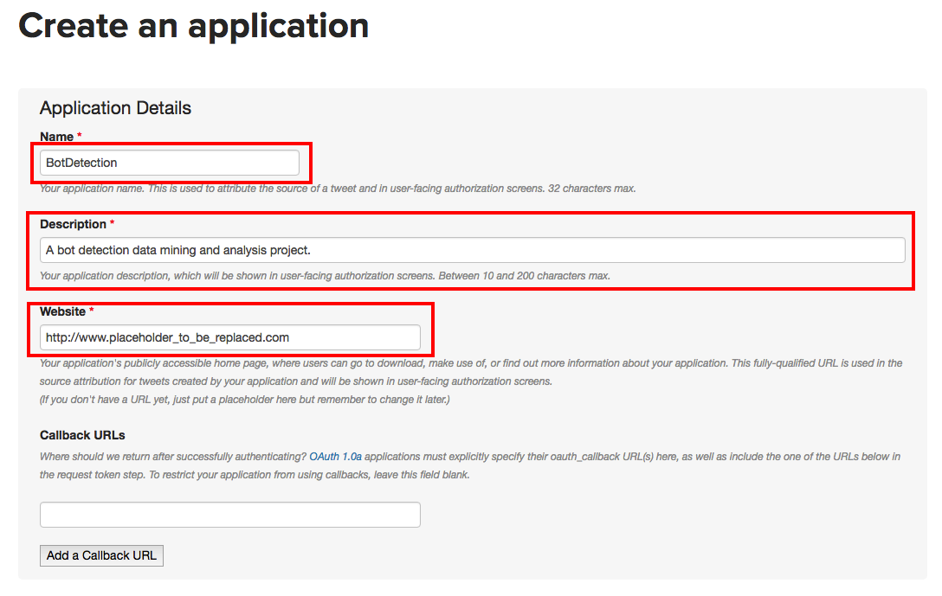

and at the bottom of the form, agree to the terms and click ‘Create your Twitter application’

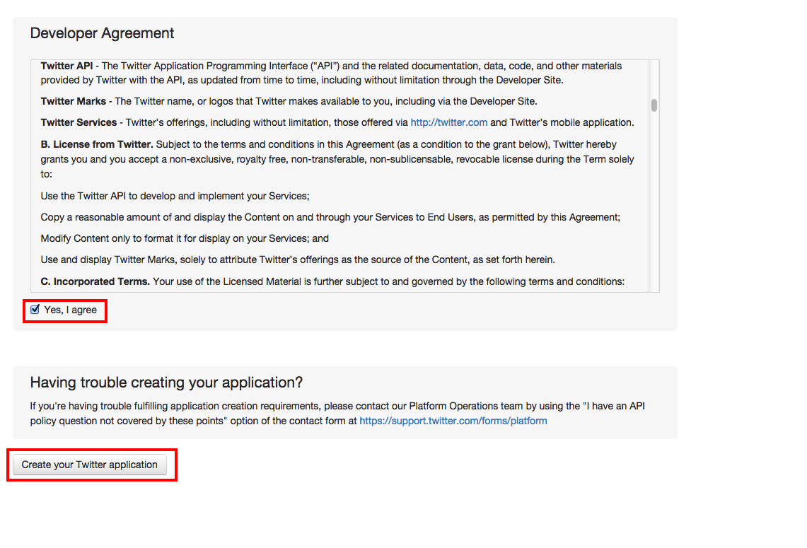

Now, it takes you to the newly created Twitter application page -

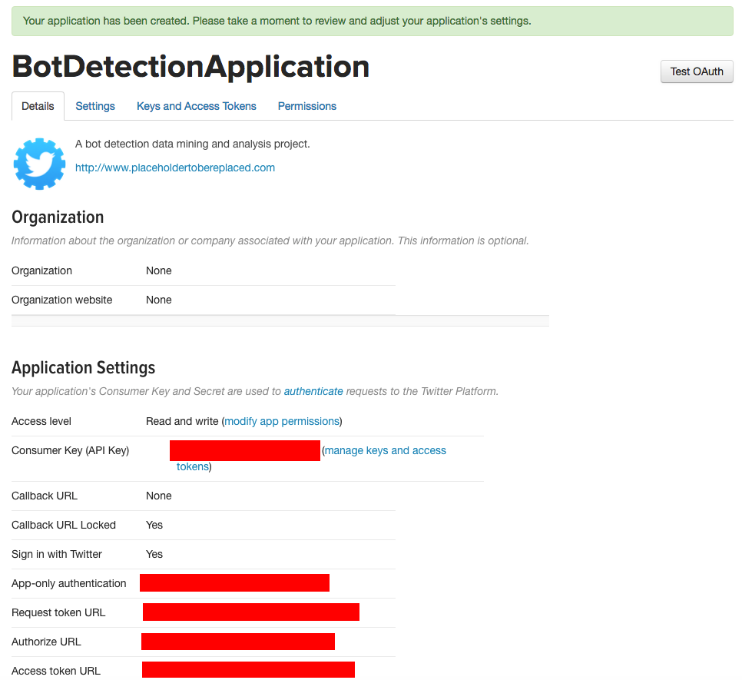

Now, an ‘Access Token’ is needed in order to make the API calls that will be made by the script. We create this ‘Access Token’ under the tab ‘Keys and Access Tokens’ and choose the option ‘Create my access token’ –

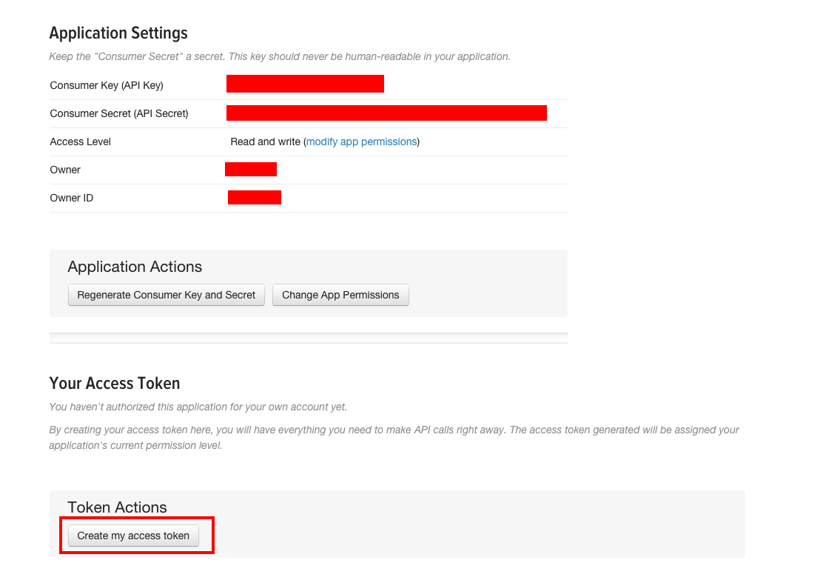

Once the ‘Access Token’ is created, the full page now contains all the attributes needed for the configuration –

Consumer Key (API Key)

Consumer Secret (API Secret)

Access Token

Access Token Secret

Consumer Key (API Key) 2t5WrolT6cQg4MMMJacv2k9nf

Consumer Secret (API Secret) 0vWFAxWbwK1IIXGkFrb2yYtAE8AbOrjRpEeAzxeEJWDOf4DOaM

Access Token 12587852-pvx0DwRsbZWanlj9bhLx0de7yXLINi79GXMfAr8l0

Access Token Secret Sdzj4i22WvaR8xboHbbpGjUUzMPWYOKWijbVwbEzuA2TH